Name:______________________ Date:_______________

Directions: You may use a scientific or graphing calculator (TI-83 or below) to complete this test. ***Put a box around all answers.***

Find the inverse of the following 1-1 function:

1. 

Find the composite function value.

1. 

The exponential function  is graphed to the right.

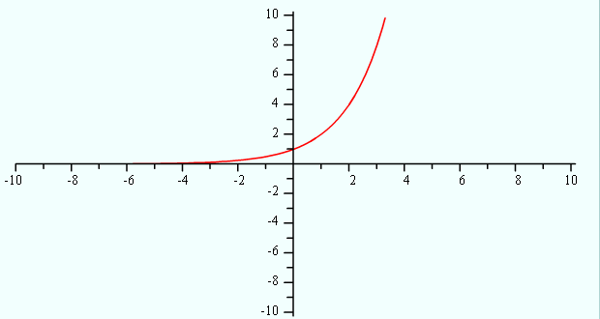

1. On the same set of axes, graph.
2. Write equation of the horizontal asymptote of g(x) in problem #3A.
3. Graph  on the same set of axes.

Rewrite the logarithm as an exponential equation:

1. 

Express as a single logarithm. Rewrite as a sum of logarithms without exponents

1. 
2. 

Find the exact value.

1. 
2.  given that 

Solve the equation. Write the **exact** solution.

1. 
2. 
3. 
4. 
5. 
6. 

Solve the equation. Write the **exact** solution.

1. 
2. Suppose that. If, what is x?

Solve the equation. Write the solution(s) rounded to the nearest thousandth.

1. 
2. Evaluate to the ten thousandths place.
3. Evaluate 
4. Suppose that $5000 is invested at an interest rate of 4.75% per year, compounded continuously. What is the balance after 3 years?
5. How long does it take the amount of money in your wallet to triple if it is invested at 7% interest, compounded quarterly? Round your answer to the nearest tenth of a year.
6. How long will it take the sample of a radioactive substance that Homer Simpson carries home from work to decay to half of its original amount, if it decays according to the decay function where k=-.157? Round to the nearest hundredth of a year.
7. If the population of a Nigeria doubles in 9 years, find the growth rate k. Assume that the population increases exponentially. Round to the nearest tenth of a percent.
8. Conservationists tagged 20 black-nosed chinchillas in a national forest in 2004. In 2005, they tagged 40 black-nosed chinchillas in the same range. If the chinchilla population follows the exponential law, how many chinchillas will be in the range 8 years from 2004?